TRUTH AND INTELLIGIBILITY
Nirmalangshu Mukherji

One of the most compelling images of modern science, as Noam Chomsky puts it, is its apparent ability to unearth the ‘real properties of matter’ from below the chaos encountered in the ‘world of ordinary experiences’. The image supports a common conception of science that views it as a harbinger of truth: the realist position. In contrast, there is a minority view in the philosophy of science which says that scientific theories necessarily fail to describe the world. In its extreme form, held notably by Nancy Cartright, this view says that scientific theories are lies: the anti-realist position. In this paper, I attempt a reconciliation of the contrasting views; in effect, I would be suggesting that the supposed opposition between realism and anti-realism need not be substantive.

1. Restriction to Intelligibility
Interestingly, Chomsky himself suggests something like an anti-realist position on science in some other writings. According to him, lessons from the history of natural sciences seem to suggest that ‘most things cannot be studied by contemporary science.’ On this issue, it seems to him that Galileo’s intuition that humans will never completely understand even ‘a single effect in nature’ is more plausible than Descartes’ confidence that ‘most of the phenomena of nature could be explained in mechanical terms: the inorganic and organic world apart from humans, but also human physiology, sensation, perception, and action.’ Developments in post-Cartesian science, especially Newtonian science, Chomsky holds, ‘not only effectively destroyed the entire materialist, physicalist conception of the universe, but also the standards of intelligibility that were based on it.’

Thus Chomsky supports Alexander Koyre’s remark that ‘we simply have to accept that the world is constituted of entities and processes that we can not intuitively grasp.’ The force of the expression ‘intuitively’ seems to be in that we cannot have direct knowledge of how the world is like; the knowledge has to be routed in terms of the resources available to our theory-building abilities. Thus, any conception of the universe is restricted to what is intelligible to us: as standards of intelligibility fall, so does our grasp of the universe. The restriction gives rise to the old irony that the world which undoubtedly gives rise to our knowledge of it cannot be sufficiently grasped by the only means available to us. Clearly, these remarks are meant to apply to the whole of science including the most ingenuous proposals in theoretical physics.

Let us suppose that this view of science applies immediately to areas such as biology. Biological systems are standardly viewed as poor solutions to the design-problems posed by nature. These are, as Chomsky puts it, ‘the best solution that evolution could achieve under existing circumstances, but perhaps a clumsy and messy solution.’ Nevertheless we are still left with at least theoretical physics, and it seems, contemporary linguistics, where, to cite Chomsky again, ‘far-reaching’ results have been reached at a sufficient remove from ‘the world of ordinary experiences.’ This domain of cognitive psychology, Chomsky holds, has enabled the adoption of ‘Galilean Style’, so far achieved only in physics. In that, contemporary linguistics offers the ‘feel of genuine scientific inquiry.’ If science cannot explain ‘a single effect in nature’, how do we explain the sense of deep understanding, of genuine scientific explanation in these selective domains? How is it that some instances of science, theoretical physics and linguistics, convey an abiding sense of truth, a view of ‘the real properties of the natural world’?

The issue is that even anti-realism is required to explain the stark asymmetry in the depth of scientific explanation between, say, theoretical physics (plus linguistics) on the one hand and meteorology and biology on the other. The ‘sense of truth’ that is felt in theoretical physics simply can’t be duplicated in terms of the available explanatory format of, say, evolutionary biology. As we will see, this issue touches the philosophy of Immanuel Kant exactly at this point.

As hinted, I find both the apparently opposing – realist and anti-realist – views to be intrinsically compelling. As cited, Chomsky himself seems to thrive on this tension: he claims at once that we may not understand a single effect in nature as well as that contemporary linguistics might have unearthed some real properties of nature. It is not difficult to appreciate the source of this tension in Chomsky’s work. As a new science, linguistic theory – alternatively, biolinguistics – initiated by him remains isolated from the rest of the established sciences, especially biology. In fact, Chomsky places the burden on biology itself: ‘how can a system such as human language arise in the mind/brain, or for that matter, in the organic world, in which one seems not to find anything like the basic properties of human language? The concerns are appropriate, but their locus is misplaced; they are primarily a problem for biology and the brain sciences, which, as currently understood, do not provide any basis for what appear to be fairly well established conclusions about language.’

So, there is a need to promote a notion of non-reductive scientific inquiry that stands on its own. The claim for the (advanced) scientific character of biolinguistics then has to be maintained without the advantage of support from the ‘basic sciences’. A natural way of upholding this claim is to deny that the basic sciences have any more claim to truth than biolinguistics. Given the anti-realist conception of science, the demand for reduction to a basic science loses force. However, Chomsky does not wish this anti-realist move to cast doubt on the scientific character of biolinguistics itself; hence, the suggested feel of ‘genuine scientific inquiry’ perhaps leading to the unearthing of ‘real properties of matter’. The tension appeals to me if only because of its philosophical complexity, apart from my fascination with the character of biolinguistic inquiry as a ‘body of doctrine’. Is there a way then of accommodating both the anti-realist and the realist drives of Chomsky in a coherent framework? More specifically, my interest is to resurrect the scientific image from within the sceptical ground charted by Chomsky.

One of the central sceptical points made by Chomsky concerns the notion of intelligibility. As Chomsky puts it, in some fundamental sense the world is unintelligible to us, and ‘we have to reduce our sights to the search for intelligible theories. We cannot hope to gain comprehension of the world, as Galileo, Descartes and Newton had hoped.’ In a way then, we are compelled to adopt David Hume’s position that Newton’s discoveries reveal the ‘obscurity’ in which ‘nature’s ultimate secrets ever will remain’. This perspective seeks to question what is taken for granted, namely, that ‘the natural sciences seek to discover basic truths about the world.’ On this assumption, the fundamental aspects of the world are progressively unveiled even if ‘the scientific enterprise remains open and evolving, and … surprises may lie ahead with unanticipated consequences, as in the past.’ The Humean conception of science, in contrast, is that science does not even aim that high. Citing Richard Popkins, Chomsky suggests that ‘the secrets of nature, of things-in-themselves, are forever hidden from us.’ Thus, we revert to the ‘mitigated scepticism’ of even pre-Newtonian English science, acknowledging the impossibility of finding ‘the first springs of natural motions’. Assuming all this, is there a route from (mere) intelligibility to truth?

2. Introducing Schemata
It is well known that Kant projected a scenario very much like Chomsky’s. On one hand, Kant had an overriding interest in the question: how is physics possible? The asking of this question clearly suggests his fascination with the abstract, universalist structure of Newtonian physics, with its wide-ranging explanatory power. To think of this feature of physics merely as a description of causal regularities is to fall into a ‘dogmatic slumber’ from which metaphysics needs to be saved. On the other hand, Kant insisted that the conception of a mind-independent reality – the noumenon – is logically incoherent since, by definition, we cannot describe it. In that sense, our conception of reality is restricted to what is intelligible to us, and intelligibility is directly related to our phenomenal grasp of the world. How then do we explain the universal empirical content of physics? How are synthetic a priori judgements possible?

A large part of the Critique of Pure Reason is a systematic investigation of this question. Kant’s general answer has two parts: constraints on experience and constraints on conceptualisation. Roughly, the human mind is endowed with the ability to form ‘strictly universal’ and, thus, ‘necessary’ propositions whose empirical content might arise when the concepts occurring in the propositions obey the ‘inner’ constraints of space and time, the locus of experiences. Setting details aside for now, the entire construction comes unstuck with what Kant called the ‘Problem of Schemata’.

In order for the non-empirical content of concepts to lend structure to the non-conceptual content of experiences, there must be an ‘intermediate’ level of structures – the schemata – that have, at once, empirical and conceptual properties. Given the framework within which the Critique of Pure Reason was placed, the conception of schemata looked like demanding a resolution of irresolvable opposites: ‘no one will say that a category, such as that of causality, can be intuited through sense and is itself contained in appearance’ (B 177). Kant opined that ‘The schematism of our understanding, … is an art concealed in the depths of the human soul, whose real modes of activity nature is hardly likely ever to allow us to discover, and to have open to our gaze’ (B 181).

The reasons for Kant’s pessimism about our ability to furnish an account of schemata are pretty obvious. As Kant observes (B 179/180), such an inquiry inevitably needs some notion of ‘productive imagination’, if the schema is to contain the ‘conditions of sensibility [that] constitute the universal condition under which alone [a] category [such as number or triangle] can be applied to any object’. This is because, as recognised since Plato formulated the one/many problem, appearances by definition are particulars and hence their grasp does not by itself contain the resources for reaching universal conditions of application. Some additional faculty of mind is required for the necessary step of abstraction (= universalisation). Let us call that faculty ‘imagination’.

However, by the very nature of the problem, the notion of imagination needs to be technical, unfamiliar in character. The familiar notion of imagination, Kant points out, is reproductive imagination such as when • • • • • gives rise to the image of number five, again a particular: the ‘image is a product of the empirical faculty of reproductive imagination’ (B 181). It is unclear what ‘image’ accompanies a ‘number in general’. In fact, ‘for such a number as a thousand the image can hardly be surveyed and compared with the concept’ (B 180). In general, ‘the schema of a pure concept of understanding can never be brought into any image whatsoever’ (B 180). The notion of imagination involved in schemata, therefore, can only be productive imagination in which ‘my imagination can delineate the figure of a four-footed animal in a general manner, without limitation to any single determinate figure such as experience, or any possible image that I can represent in concreto, actually presents’ (B 181). In that sense, ‘the schematism of our understanding, … is an art concealed in the depths of the human soul’ (B 181).

Nevertheless, it is possible to distinguish between our ability to furnish a ‘transcendental’ analysis of the concept of schemata, and the recognition that, in entertaining synthetic a priori thoughts, the human mind has somehow solved the problem of schemata. To consider a related analogy, there is no doubt that we are able to report on what we see, even if a cognitive account of how we do so could be elusive. Notice that, when the problem is solved by the mind, the resources remain within the bounds of intelligibility; at no point does Kant (or Jackendoff) require to postulate properties of the (mind-independent) world itself to show how we come to have knowledge of it.

The solution of the problem requires, as we saw, a ‘top-down’ availability of ‘strict universality’ as well as a ‘bottom-up’ availability of structured experience: we do not know how the mind puts them together, but we know that it is done somehow. Generalising from categories to laws of physics, the solution requires the incorporation of phenomenological understanding under abstract algebraic representations: in other words, the covering law model of scientific explanation.

More generally, the way Kant sets up the problem, two global epistemological moves are barred in effect. For one, we cannot address the problem of schemata by simply allowing a direct grasp of the categories themselves. Such Platonism is ruled out because categories themselves are just a priori contributions of the mind; they do not apply anywhere until they are filled with the content of sensibilia. For another, we cannot deny that we have at least a restricted universal conception of the world, as the body of Newtonian physics testifies. To explain the phenomenon of physics in terms of habits of regularities formed out of the grasp of particular sensible objects is to fall into a (Humean) ‘dogmatic slumber’. If the framework of schematism works then we have some hold on how universal conceptions can be reached by beginning with sensibilia alone.

3. Order of Sensations
In an enigmatic and (to my knowledge) largely neglected passage (B 183), Kant makes some preliminary attempts to show how progressive abstractions on sensibilia might give rise to stable conceptions of the world, although, as he insisted, there is no independent hold on these conceptions except through the ‘senses’ and the a priori contributions of the mind that give rise to them (the conceptions of the world). As he put it, ‘the objects which corresponds to sensation is not the transcendental matter of all objects as things in themselves (thinghood, reality)’ (B 183). To that end, Kant introduced the notion of ‘sensation in general’ to suggest that it ‘points to being (in time)’ (B 183).

Before we develop the suggestion, notice the Heideggerian theme of ‘being in time’. Kant is suggesting, as noted, that the notion of ‘reality’ (being) that sensations point to is not being per se; no such thing can be grasped in the framework of the Critique. What can be grasped, at most, is some notion of being that is intrinsically related to the ‘inner sense’. To put it differently, there ought to be some process wholly in the inner sense (=mind) that points to some object in the outer sense (=external world): the inner sense projects the external world for us. How do we conceptualise this effect while denying the conception of things in themselves?

Within the austere framework of the Critique, the only available resource for capturing the required distinction – between the world as projected and the world as such – are the notions of space and time. As developed earlier in the part of the Critique titled ‘Transcendental Aesthetic’, both space and time are viewed as a priori forms of intuition, that is, both are contributions of the mind for grasping sensible intuitions. In Kant’s terms, space and time are not properties of things and events as commonly believed; rather, they give forms to sensations as they appear in the otherwise ‘blind manifold’. However, for complicated reasons that we need not get into, space is viewed as an outer form of intuition – an ‘outer sense’ – while time is viewed as an ‘inner sense’. Now, if the postulated sensations in general are to arise from local, particular sensations themselves such as to give rise to some restricted conception of reality in the outer sense, the process that generates sensations in general can only be a function of the inner sense. Since time is the only concept available in the inner sense, sensations in general can only point to being in time. To my understanding, the notion of time plays no other role in the context of schematism beyond providing a ‘template’ – ‘merely the form of intuition’ – for sensations in general. Hence, I will refrain from examining this (puzzling) aspect of Kant’s programme on schemata.

Turning to the basic suggestion of sensations in general, Kant’s idea is that sensations come in degrees (magnitudes) ranging from ‘nothingness’ – empty of magnitude – to complete ‘fill out’ even though its representation of the object otherwise remains the same. To use the visual analogy, we can see an object with its full details on close quarters—the details begin to drop out as the object zooms out of view. As the process continues, there comes a point when the last of the details drops out and the object vanishes (ceases to exist in the visual field). Transferring the analogy to the activities of the inner sense, it looks as though the mind is able to abstract away from the strong and vivid particularity of sensations – of the same object, to emphasise – to sensations that are less and less ‘filled out’. Of interest is the point at which the most abstract sensation turns into nothingness (non-being). The penultimate state of the inner sense then is the most abstract form of being that the mind can construe in some sense. Kant’s novel suggestion seems to be that this penultimate inner sense of the being can be called ‘sensation in general’, which presents the object in its maximum generality while continuing to be a sensation.

As just hinted, the most interesting aspect of these suggestions – the reason why I invoked Kant in the context of this paper – is the apparently counter-intuitive claim that sensation in general – not (the original) sensations themselves – points to the being. If I understand the thrust of Kant’s proposal correctly, we are led to a rather strong interpretation that the process of abstraction – descent towards non-being – is in fact an indicator of more reality than the full sensation with all the details filled out. In that sense, there is a thin line between being and non-being which is not captured in the thickness of sensations; it is grasped only in their thinness. I will presently cite some textual support for this (strong) interpretation.

This interpretation contrasts with a possible weak interpretation in which the ascent and descent of sensations is merely a way of reinforcing the function of time such that the empirical intuition that sensations can both fill out or reach a vanishing point is a sure indicator of ‘something’. Under this interpretation, Kant is leaning on the play of sensations in time to thwart the idealist: the idealist has no resources to explain the growth (or the recession) of the sense of reality even if sensations, at no point thick or thin, signal things in themselves.

The weak interpretation is not inconsistent with the strong one. Even if the up-and-down movement of the content of experiences itself is a pointer to reality, it only follows that grades of sensations point in a general way to reality. We do not yet know which grade of sensation points to the ‘maximum’ of reality. At this point, the strong interpretation suggests that the relation between fullness of sensations and fullness of reality is an inverse one: as there are more sensations, there is less reality up to the penultimate state, after which the sense of reality disappears. Fullest sensation then is not an indicator of being, but that of particularity, which is neither being nor non-being—it is just overwhelming appearance. Being, in contrast, is a subterranean conception that does not manifest itself directly in sensations; hence, the need for productive imagination.

As Kant puts it, the ‘schema of substance is permanence of the real in time’ (B 183: emphasis added); it is a ‘substrate’ of empirical determination in time that abides ‘while all else changes’ (B 183). In other words, the sense of reality (the schema of substance) begins to emerge when ‘what is transitory passes away in time’, but ‘what is non-transitory in its existence’ in ‘the field of appearance’ persists (B 183). Sensations, therefore, contain both transitory and non-transitory aspects; the progressive extraction of the non-transitory elements of sensations by productive imagination yields sensation in general which, as a best fit, is a more compelling pointer to being. The entire weight of the proposal thus hinges on the role played by productive imagination in extracting sensation in general, which is the empirically significant conception of the substratum.

4. Productive Imagination
Unfortunately, beyond some general comments on causality and the like, Kant does not elaborate on how the suggested abstractions in sensation are to be understood. To pursue the project, I will suggest that there is a variety of ways in which such abstractions can be generated by productive imagination. Consider Fig. (I), which consists, respectively, of a photograph, a sculpture, and a line drawing of Gandhi.

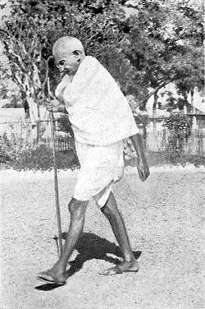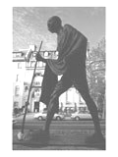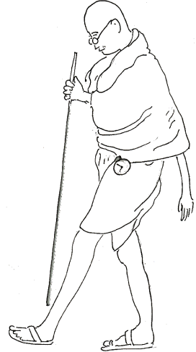
(a) (b) (c)

Fig. I. (a) Photograph from the Dandi march of 1930, (b) Photograph of Gandhi statue in Washington D.C., (c) Line drawing posted at www.kamat.com/kalranga/iink/klk37.htm (artist’s name not cited).

It is important to note, pace Kant, that even (a) is a product of imagination with accompanying abstractions: it enables us to ‘see’ Gandhi without his presence. However, (a) represents reproductive imagination; it is a (mere) copy of the original thick sensations. In contrast, (b) and (c) are generated by productive imagination in that the mind abstracts away from the original sensations even further while deliberately losing details. In (b), the mere posture is captured with more ‘volume’ as the properties of the gait are highlighted – notice the length of the legs. On the other hand, (c) is just an outline that abstracts away from the volume. In (b) and (c), thus, there is a descent from the original sensation in two different directions. The point is that the descents of sensation bring out more of the ‘essence’ of the real meaning of (a). In other words, (b) and (c) suggest how the transitory aspects of (a) may be progressively removed by productive imagination to focus on the non-transitory ones.

A different play of productive imagination is captured in Fig. II(b). The striking portrait of Gandhi retains both the volume and the outline of the original in II(a) (let us suppose), but it emphasises some aspects while de-emphasising others, turning (b) thus into an example of abstract expressionism.
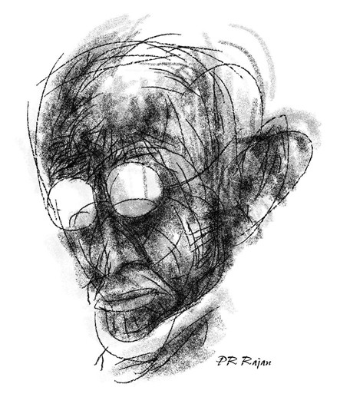
(a) (b)
Fig. II. (a) Gandhi in prayer, Mumbai, September 1944, courtesy Gandhi Serve Foundation, (b) Portrait of Gandhi by the graphic artist P. R. Rajan posted at www.pbase.com/dehl/image/77411393

The move seems definitive in this case because the abstract character of someone (deep) in prayer – the real goal of the artistic imagination – cannot be fully brought out from the common arrangement of anatomical parts alone. II(b) thus represents productive imagination as playing out in a more abstract direction in which much of the transitory Gandhi is lost as the conception of prayer emerges. Nonetheless, these portrayals of Gandhi suggest how the productive imagination works to abstract away from the sensations of an individual object while retaining its individuality: the abstractions were designed to bring out the figures of Gandhi in march and Gandhi in prayer. Kant’s basic problem, however, was to understand how the sensations of an individual – and sensations, by definition, must be of an individual – may give rise to (general) concepts and categories.

Fig. III contains a picture of a Spanish bull, and Picasso’s famous sketches of states of the bull. In my view, Picasso’s work combines each of the features of abstraction – volume, outline, and expressive gesture – suggested individually in the portraits of Gandhi. Hence, it is a more advanced artistic achievement. To show the degree of abstraction attained by Picasso, III(a) represents an actual younger, leaner bull that is trained for the fights (Picasso’s deep interest in bullfights is well known).

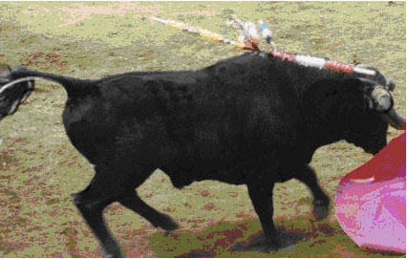
(a)
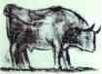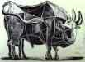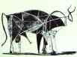
(1) (2) (3)
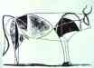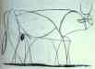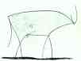
(4) (5) (6)
(b)
Fig. III. (a) Photograph of a Spanish fighter. (b) Pablo Picasso. States of The Bull. 1945. Lithography. The Museum of Modern Art, New York, USA [only six (designated as 1-6) of the original eleven states shown here].
From a younger bull at state 1, Picasso develops a fully-grown bull at state 2 to capture the desired expression of aggression: state 2 in that sense is an instance of abstract expressionism. As the abstraction proceeds, the representation turns to a ‘younger’ bull at state 4 with much of the transitory features of the adult bull removed. As sensations descend further, the volume gives way to a series of progressively abstract outlines ending in what might be viewed as the ‘minimalist’ bull at state 6. The suggestion is that, once the last state is reached, we cannot take anything away from it if we wish to retain the bull: any further state turns it into non-being. In that sense, the penultimate state is the being of the bull, its essence.

Picasso’s work is a masterpiece because although it does use the natural capacity of productive imagination, it requires skill and reflection of a very high order to actually articulate the sensations in general that the mind grasps. In contrast, consider Fig. IV, which consists of the picture of a common bull and the well-known paleolithic cave painting. The painting shows that the human mind was endowed with sophisticated productive imagination from an early stage. Yet, the product of that imagination reaches only an intermediate level of abstraction. It needs a Picasso – that is, an entire artistic tradition and a brilliant mind – to take the next few steps.
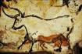
(a) (b)

Fig. IV. (a) Photograph of Texas longhorn, (b) Red Bull, cave painting discovered in Lascaux, Dordogne, France, ascribed to the upper paleolithic, c. 15000-18000 BCE

5. Galilean Style
As Cedric Boeckx rightly points out, Picasso’s states of the bull does suggest a generalisation from the minimalist conception of a bull to the abstractions achieved in advanced scientific theories. For example, Picasso’s project suggests an analogy for the sort of abstraction attained from Newtonian mechanics to the theory of relativity, or from the government-binding framework to the minimalist programme in linguistics. However, despite the genius of Pablo Picasso, the character of abstraction reached so far is not enough for the issue in hand, namely, the notion of scientific truth. The crucial difference between Picasso’s enterprise and scientific theorising is that science is a body of propositions, not of pictures, although scientific propositions can be aided by or give rise to (abstract) pictorial representations, as we will see. More specifically, in an advanced science such as physics, the propositions are invariably mathematical expressions that are totally devoid of direct pictoriality however abstract. Physicists believe that Physics had to ‘free itself’ from ‘intuitive pictures’ and give up the hope of ‘visualizing the world’. So the sensation in general pointing towards being captured in a scientific proposition (if at all) is even more abstract than the final, minimalist step of Picasso. As noted, in Picasso’s line of abstraction, anything beyond that step points to non-being. How then is being captured in science?

The answer is obvious from the way we formulated the problem. For physics to represent reality in the abstract, it must focus only on those aspects of sensation in general that are mathematically formulable. In other words, physics so abstracts from thick sensations – the ‘world of common experience’, to cite Chomsky – as to unearth an abstract scheme which some mathematical formulation can generate. Fig. V depicts the phenomenon.


(a) (b) (c)
x = X + (R – r) * cos è
y = Y + (R - r) * sin è
(d)
Fig. V. (a) Photograph of the bronze statue of Lion Pillars at Sarnath with Asoka Cakra at the base, (b) Asoka Cakra cropped from the photograph and enlarged, (c) Computer generated image of the cakra, (d) the mathematical equation that generates the form of the cakra

Each of Figs. V(a) to (d) enables the mind to grasp the form of the Asoka Cakra in different ways. While (a) is embedded in the context of a reproductive imagination, (b) represents a part of it focusing on the cakra itself. The equations in (d), or variations thereof, generate figures, say, in a computer, as shown in (c). My point is that (c) represents, at best, something like the last step of Picasso; hence, it could have been obtained without (d), the equations. It stands to reason that something like (c) must have been entertained by the human mind in order for the scientific mind to come up with a mathematical representation, as in (d), which replicates, to a close approximation, the abstract form already entertained.

Yet, (c) by itself does not represent scientific progress; it represents at most ‘artistic’ progress. In that very specific sense, science takes off from where Picasso leaves sensation in general. We return to the significance of this (scientific) step in the next section. For now, the problem is that the considerations just mooted are necessary, but, by no means, sufficient for physics, because physics is not merely a body of mathematics. The equations in V(d) are just mathematical formulae for generating certain geometrical shapes such as V(c); they are not even empirical generalisations. In that sense, these equations do not capture any aspect of reality.

Mathematical physics, at least since Newton – the central topic for Kant – aims much higher. Its mathematical formulae are not only empirical in character, they also signal vast generalisations: Newtonian mechanics, theory of relativity, quantum theory, and now string theory are often viewed as theories of ‘everything’. So, the really puzzling feature of the fundamental laws of physics is that they are at once mathematical in character and representations of large aspects of the universe. Authors such as Steven Weinberg in fact trace the realistic significance of physics to its mathematical formulations: ‘we have all been making abstract mathematical models of the universe to which at least the physicists give a higher degree of reality than they accord the ordinary world of sensations.’ Weinberg and others have called this form of explanation in physics the ‘Galilean Style’. The style, according to these authors, works as a foundational methodological principle because of Galileo’s insight that nature ‘always complies with the easiest and simplest rules’: nature is ‘perfect and simple, and creates nothing in vain.’ How does this (foundational) aspect of physics with its profoundly abstract and, thus, seemingly non-sensual character mesh with the Kantian project? To which being do the constructions of physics point to, and at which descent of sensation? To put it differently, why do the fundamental laws of physics seem intelligible to us, given our bounds of sense?

Once again, the formulation of the problem suggests how it is to be addressed. We recall that in the previous set of pictures in Fig. V, the aspect of ‘sensation’ in the mathematical symbolism accrued from the fact that these equations formally described a figure that matched, in relevant respects, the descending sensation captured in the (enhanced) reproductive imagination incorporated in V(b). There is no ‘direct’ descent from (b) to (c); if anything, there is, arguably, an ascent from (d) to (c). In that sense, the link between the reproductive imagination and the final productive imagination is, at best, indirect. It stands to reason that, in order for productive imagination to turn even more abstract for approaching Galilean ideals, the link with any possible reproductive imagination is likely to be even weaker, though the link will continue to be non-empty according to Kant’s framework.

It seems to me that these austere conditions can be met if we suppose that any further abstraction in the final product requires that the descent of sensations begins with productive imagination itself, and not with reproductive imagination. This will contrast with, say, the abstractions captured in Picasso’s bull in which the descent begins with intermediate states, which in turn are more directly linked to reproductive imagination. The required (ultimate) link with reproductive imagination then will be diffused; its trace would have been lost in the complex history of human thought. The sensational content of advanced scientific theories is that sense is far more elusive and indirect than the most perspicuous examples of minimalist art.

To illustrate, I will consider the form of representation achieved in Niels Bohr’s model of the atom. I have chosen this example because this model is often viewed as a ‘planetary’ model suggesting that an existing phenomenon – the orbit of planets around the Sun – was the (analogical) trigger for Bohr to develop the idea of electrons circling the nucleus in discrete orbits. The suggestion thus is that Bohr developed his model of the atom by abstracting away from the ‘picture’ (=reproductive imagination) of the solar system. Without denying that the model of the solar system could have played some analogical role in this case, I will suggest that the facts of the case do not support the idea that the scientific thinking ensued from some reproductive imagination.

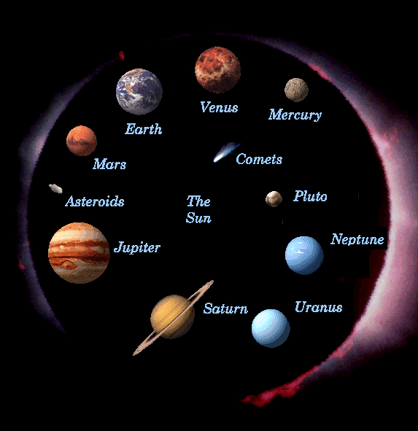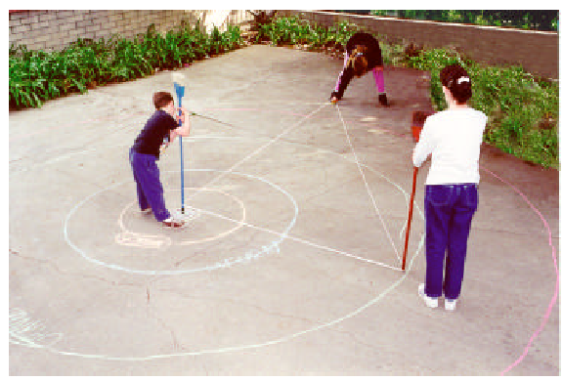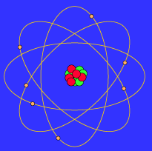
(a) (b) (c)

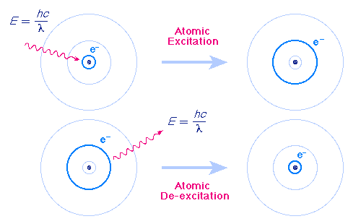
(d)

Fig. VI. (a) ‘Projection’ of the planetary system based on NASA photographs, (b) drawing of the solar system from known measurements, (c) artistic impression of Bohr’s model of atom, (d) graphic representation of atomic excitation based on Bohr’s principle.

The representations in Figs. VI(a) to (d) depict the situation. VI(a) is a ‘static’ picture showing the assembly of planets around the Sun. It is important to note that (a) itself is not a photograph; it was composed from photographs of individual planets taken by a variety of spacecrafts. It is easy to see that there is no direct photograph of the (entire) solar system – the solar system is a construction of the human mind acting on pieces of information over several centuries. As shown in VI(b), any pictorial representation of the solar system is an abstract and elaborate play of human productive imagination that constructs the system with the aid of bits of direct information combined with geometrical forms generated from mathematical symbolism.

In any case, for Bohr, even the individual photographs and pictures of partial orbits were not available. VI(c) is an ‘artist’s’ imagination of the structure of an atom, modelled on the analogy of the productive image of the solar system: VI(d) shows a graphic – not pictorial – representation of excitation and de-excitation of an atom in terms of Bohr’s remarkably simply formula that determines the orbits of electrons around a nucleus. Elements of (d) point to aspects of being – ‘the real properties of matter’ – in almost total absence of elements of sensation. Yet, the point remains that the descending, minimalist sensation captured in (d) does help generate the artistic conception of the atom in (c) which, in turn, is intelligible to us because it relates to the range of sensation that gave rise to the model of the solar system. Needless to say, such analogical moves on sensations will be harder to locate for even more abstract formulations of physics.

6. Truth and the Galilean Style
Having grounded the basic elements of the Galilean Style in a broadly Kantian framework of intelligibility, we are in a position to return to the original issue of the truth-bearing character of advanced scientific theories. It must be recalled that we cannot escape the fact that the properties of nature are disclosed to us in so far as they are intelligible in terms of the theories we formulate about them. This restriction in intelligibility is the source of the lie. However, ‘intelligibility’ is a graded concept. If certain domains of inquiry open themselves for human understanding on the basis of the most stringent standard of intelligibility, then, from within the closed space of intelligibility, so to speak, we get a glimpse of the ‘real’. As Kant pointed out, there is no direct inquiry into the real as such; we are bound by the phenomena and the interpretation that we place on them. Yet we hope with some justification that, with the highest standard of intelligibility, the interpreted domain resembles reality as closely as is possible. In effect, as the classical standard of intelligibility of grasping the-world-as-it-is falls, the bar of formal standard of intelligibility is raised a few notches to recover some of the world lost.

The Galilean Style offers such a standard of intelligibility. If the phenomena in a certain domain are interpreted with the help of a minimal set of abstract principles that generate, in a long deductive chain, some of the salient features of the phenomena itself, then the chances are that these principles describe the real properties of nature. This, then, is the best we can get. Post-Galilean physics abounds in such principles; contemporary linguistics is a more recent example. Truth, therefore, is a consequence of intelligibility of the highest grade, rather than the mystical property of the mind that grasps the real properties of the world directly. The burden thus shifts to the anti-realist to explain why the adoption of the Galilean Style in physics in fact enhances the explanatory power.

It is interesting that the intelligibility-geared notion of truth that has just been advanced also explains the severe restrictions under which it may be attained. Recall the distinction between Picasso’s final, minimalist, sketch of the bull and the formal pictorial representation of the Asoka Cakra generated from a pair of simple mathematical equations. The question is: could we have taken the next, formal, step for Picasso’s minimalist bull as well? In other words, is there a mathematical expression that formally generates a figure that representationally matches the artistic conception of the minimalist bull?

Even a cursory look at the image of the bull suggests that, despite Picasso’s minimalist efforts, the form is pretty complex and irregular; the form continues to be ‘biological’ in character. There could be mathematical expressions that generate this form, but the chances are that they will be highly complex. For the same reason, those expressions will be very specific to this particular form; they are not likely to generalise for the rest of nature. The sinusoidal equations that generate the cakra, in contrast, exploit the symmetry and the periodicity of the desired form, which replicates in nature in abundance. Still, as noted, even the equations for the cakra and the form generated thereof are very restrictive in character: elementary geometry and computer science do not pass as theoretical physics.

So, the abstract generalisations captured in theoretical physics need to appeal to much higher orders of symmetry and periodicity. The simplest forms thus are the hardest to identify. Much of the history of science illustrates this point in the actual body of scientific work. Thus Chomsky observes that ‘genuine theoretical explanations seem to be restricted to the study of simple systems even in the hard sciences … By the time you get to big molecules, for example, you are mostly describing things.’ ‘Nature’s ultimate secrets,’ to cite David Hume again, remain shrouded in ‘obscurity’. On the rare occasions in which those secrets are revealed, scientific imagination confirms nature’s ‘drive for the beautiful’.

Notes:

Noam Chomsky, ‘Linguistics and Cognitive Science: Problems and Mysteries,’ in The Chomskyan Turn, ed. A. Kasher (Oxford: Basil Blackwell, 1991), pp. 26-53.
See Nancy Cartright, How the Laws of Physics Lie (Oxford: Oxford University Press, 1983).
Noam Chomsky, ‘Language and the Rest of the World,’ Bose Memorial Lecture in Philosophy, Delhi University: 4 November 2001. See also Wolfram Hinzen, Mind Design and Minimal Syntax (Oxford: Oxford University Press, 2006).
Noam Chomsky, ‘Language and the Rest of the World,’ lecture cited.
Ibid.
Ibid. Emphasis added.
Alexander Koyre, cited in Noam Chomsky, ‘Language and the Rest of the World,’ lecture cited.
Noam Chomsky, The Architecture of Language, eds. N. Mukherji, B. Patnaik and R. Agnihotri (New Delhi: Oxford University Press, 2000), p. 18.
Noam Chomsky, ‘Linguistics and Cognitive Science: Problems and Mysteries,’ in The Chomskyan Turn, ed. A. Kasher (Oxford: Basil Blackwell, 1991), p. 51.
Cited in Massimo Piattelli-Palmarini, ‘Foreward’ to J. Uriagereka, Rhyme and Reason: An Introduction to Minimalist Syntax (Cambridge, Mass.: Massachusetts Institute of Technology Press, 1998), p. ix.
Noam Chomsky, ‘Language and the Rest of the World,’ lecture cited.
? Noam Chomsky, ‘Linguistics and Cognitive Science: Problems and Mysteries,’ ed. cit., p. 51.
Noam Chomsky, The Minimalist Program (Cambridge, Mass.: Massachusetts Institute of Technology Press, 1995), pp. 1-2.
See Wolfram Hinzen, ed. cit.
See forthcoming Nirmalangshu Mukherji, The Primacy of Grammar, Ch. I.
Noam Chomsky, ‘Language and the Rest of the World,’ lecture cited.
Ibid.
Ibid.
Ibid.
Ibid.
Ibid.
The discussion on Kant in this section and the next is restricted to Immanuel Kant’s Critique of Pure Reason, Trans. N. K. Smith. London: Macmillan, 1929. All references are to the second edition (B). I am much indebted to Susrut Ray and Rimina Mohapatra for help with the sections on Kant. Ray’s own work [Understanding Graphical Expressions [Ph.D. Dissertation] (Delhi: University of Delhi, 2007)] on these aspects of Kant’s programme is a significant contribution to contemporary studies on Kant.
See Ray Jackendoff, Foundations of Language: Brain, Meaning, Grammar, Evolution (Oxford: Oxford University Press, 2002).
Cedric Boeckx, Linguistic Minimalism: Origins, Concepts, Methods, and Aims (Oxford: Oxford University Press, 2006), pp. 96-97.
Noam Chomsky, ‘Linguistics and Cognitive Science: Problems and Mysteries,’ ed. cit., p. 51.
From A. M. Ponraj, ‘Indian National Insignia: line drawings based on Kolam, parametric equations and L-system,’ posted at http://www.niitcrcs.com/iccs/iccs2004/Papers/332%20A%20M%20Ponraj.pdf.
? Steven Weinberg, ‘The Forces of Nature,’ in Bulletin of the American Academy of Arts and Sciences, 29 (1976): 13-29.
See Steven Weinberg, Dreams of a Final Theory (New York: Vintage, 1993) and Noam Chomsky, Rules and Representations (Oxford: Basil Blackwell, 1980).
Galileo quoted in Cedric Boeckx, ed. cit., p. 112.
See Mary B. Hesse, Models and Analogies in Science (Notre Dame, Ind.: Notre Dame University Press, 1966).
See Ian Stewart, Nature’s Numbers: Discovering Order and Pattern in the Universe (London: Weidenfeld and Nicholson, 1995) and What Shape is a Snowflake? (London: Weidenfeld and Nicholson, 2001). See also Sean Carroll, Endless Forms Most Beautiful (New York: Norton, 2005).
Noam Chomsky, ‘Language and the Rest of the World,’ lecture cited.
Ernst Haeckel quoted in Noam Chomsky, ibid. Works Cited: Boeckx, Cedric. Linguistic Minimalism: Origins, Concepts, Methods, and Aims. Oxford: Oxford University Press, 2006. Carroll, Sean. Endless Forms Most Beautiful. New York: Norton, 2005. Cartright, Nancy. How the Laws of Physics Lie. Oxford: Oxford University Press, 1983. Chomsky, Noam. Rules and Representations. Oxford: Basil Blackwell, 1980. ---. Chomsky, Noam. ‘Linguistics and Cognitive Science: Problems and Mysteries’. The Chomskyan Turn. Ed. A. Kasher. Oxford: Basil Blackwell, 1991. pp. 26-53. ---. Chomsky, Noam. The Minimalist Program. Cambridge, Mass.: Massachusetts Institute of Technology Press, 1995. ---. Chomsky, Noam. The Architecture of Language. Eds. N. Mukherji, B. Patnaik and R. Agnihotri. New Delhi: Oxford University Press, 2000. ---. Chomsky, Noam. ‘Language and the Rest of the World’. Bose Memorial Lecture in Philosophy. Delhi University: November 4, 2001. Hesse, Mary. Models and Analogies in Science. Notre Dame, Ind.: Notre Dame University Press, 1966. Hinzen, Wolfram. Mind Design and Minimal Syntax. Oxford: Oxford University Press, 2006. Jackendoff, Ray. Foundations of Language: Brain, Meaning, Grammar, Evolution. Oxford: Oxford University Press, 2006. Kant, Immanuel. Critique of Pure Reason. Trans. N. K. Smith. London: Macmillan, 1929. Mukherji, Nirmalangshu. The Primacy of Grammar. Forthcoming. Ray, Susrut. Understanding Graphical Expressions [Ph.D. Dissertation]. Delhi: University of Delhi, 2007. Stewart, Ian. Nature’s Numbers: Discovering Order and Pattern in the Universe. London: Weidenfeld and Nicholson, 1995. Stewart, Ian. What Shape is a Snowflake? London: Weidenfeld and Nicholson, 2001. Weinberg, Steven. ‘The Forces of Nature’. Bulletin of the American Academy of Arts and Sciences 29 (1976): pp. 13-29. ---. Weinberg, Steven. Dreams of a Final Theory. New York: Vintage, 1993.

