Competitive Examinations
One of the distinguishing characteristics of the higher education scenario in recent times has been the dominance of competitive examinations. Immediately after Class XII, it is impossible to get into any professional course on the basis of the school leaving marks alone. From medicine to engineering to fashion design- every single course and indeed institution demands that one sits for an open examination to get admission. And this continues till after one graduates- for post graduate studies in medicine, engineering, computer applications etc. Finally, a whole range of government/public sector jobs are also available only after clearing competitive examinations, the coveted Civil Services being only the most well known.
There is of course a stated rationale behind this proliferation of competitive examinations. The logic goes as follows: given that the standards of various examinations ( CBSE, State Boards, Universities etc.) are so different, there is no way we can compare the marks obtained in these examinations and use them to assess the quality of the candidate. Hence, we carry out our own assessment. Of course, it is assumed by each agency that their examination in some sense does indeed assess the true quality of the student!
Without going into the merits and demerits of this logic, in this piece, we want to try and see if the performance in the entrance examinations does indeed measure the capabilities of the student. More specifically, we want to see if there is an element of chance in the performance.
It is a common sentiment that the passing in a competition is, apart from many other factors, a matter of chance. Here we attempt to give this statement a fair measure of objective meaning with regard to one kind of method of testing, namely multiple choice objective examinations. Multiple choice objective examinations have reduced dependence on long or essay type questions and eliminated the uncertainty associated with the multiplicity of human examiners. This format makes the scripts simple to evaluate and in fact machine readable.
This elimination of the human examiner has led many to believe that the result of an objective test is sacrosanct. Of course, there is no doubt that the subjectivity which might creep in because of a human examiner is eliminated with this format. However, to jump from this to say that the result of a multiple choice examination is a true representation of the inherent capabilities of the examinee is where the problem arises.
For instance, if the questions were replaced by a different set of questions which are of equal level of difficulty, would the marks scored by the examinees remain more or less the same? If not, then there is a hidden sampling error in the choice of questions. This error can, in principle, be analysed by making the examinees undergo many equivalent tests over a short span of time. Clearly, this is not a very feasible experiment with any reasonable sample of students.
Instead, to try and understand the inherent sampling errors in Multiple Choice Tests, we adopt another procedure which mimics the actual experiment closely. Our experiment is based on the actual data from the entrance examination to a professional course which was taken by over 57,000 students. The actual test consisted of 2 papers, with 100 questions in each paper and the total marks of each student in the 2 papers were used to rank the students. Of course, since the marks were only out of 200 and the number of students was many times that, there was a lot of degeneracy- a large number of people had the same rank and there were gaps in the ranks whenever more than one person gets the same mark and hence rank.
With this original data set, we prepared another data set. This fictitious data set comprised of 10 question papers with 50 questions each. These 50 questions were taken randomly from the original 100 questions in one paper. ( we repeated the whole exercise with the other paper with no substantial change in the results). In this way now, we had 11 test papers for each candidate- one original one and 10 fictitious ones.
Since the fictitious papers were made from the original test paper, the marks of each candidate in each of the 10 fictitious papers were known. Thus each candidate had 11 marks and ranks- one original and 10 in the fictitious papers. In fact, it is more complicated than this- there are several students associated with each original rank and each of these students has 10 other fictitious ranks.
With this data, we are able to see something very interesting. We plot the original data on a graph, i.e. make a plot of the ranks in the original data vs the corresponding marks. This curve is shown as the unbroken line in figure 1.
At each rank, we now take the number of students who got that rank and find their ranks and marks in the 10 fictitious papers. Typically, there are around a hundred students at most ranks and remembering that each of these students has 10 other ranks, we get a large enough sample to warrant a statistical interpretation. We take this distribution and compute its mean and standard deviation, which gives us an estimate of the spread around the mean.
This information is plotted in Figure 1 as the broken line. The data points are the mean of the distribution at each rank and the error bars are the standard deviation.

To make the data more obvious, 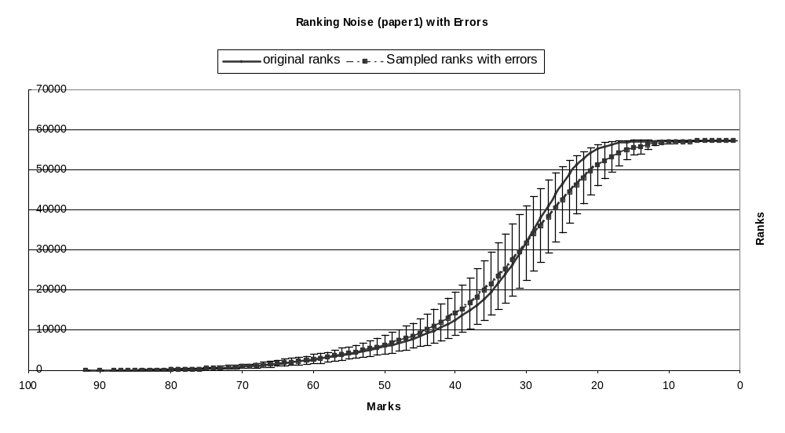the same plot for the first 30 distinct ranks is shown in figure 2.
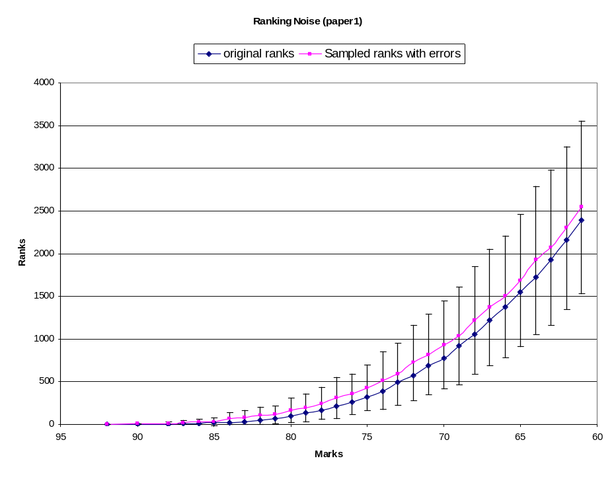

To further study the samples, we choose an arbitrary rank in the original paper. We take a rank near 1000, assuming that in a typical examination, rank 1000 would be the qualifying rank. At rank 1060 (in the original paper) , we take the 164 students who have got this rank. For these 164 students, we consider their ranks in each of the 10 fictitious papers. Thus we have in all 1640 ranks which is a large enough number to warrant a statistical interpretation. We take these 1640 “ranks” in the fictitious papers and find the mean and the standard deviation of this distribution. The distribution is shown in Figure 3.

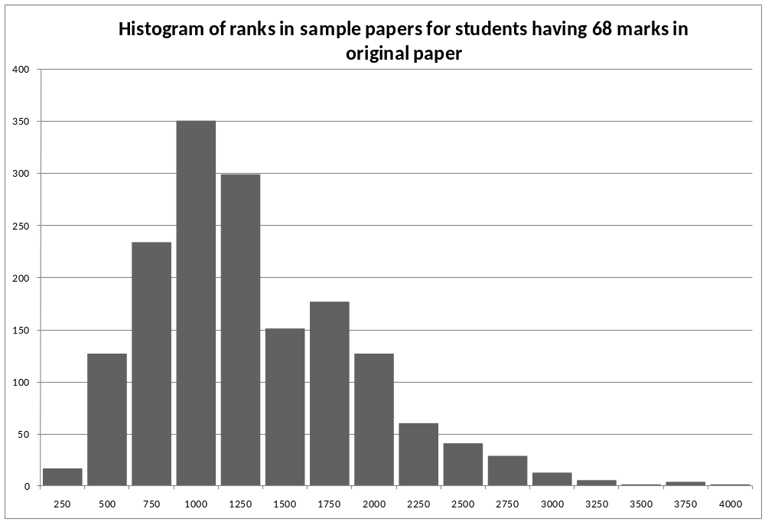

It is interesting to see the same graphs for Paper 2. The second paper shows a trend similar to the first paper. In detail however the number of candidates at each rank is more than in the Paper 1. The curve therefore rises more steeply and the standard errors are also a little higher.

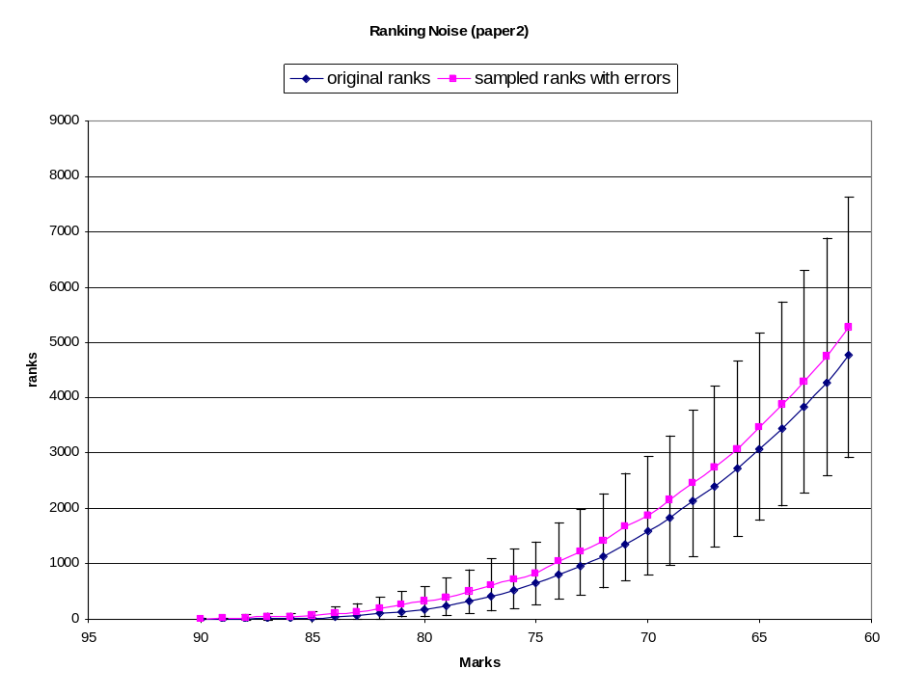

The detailed graph of the sample in this case is shown for the rank 968. The number of candidates at this rank in this paper is 185. This histograms presented is therefore for 1850 ranks. The mod of the distribution is near 1000 and the quartiles are near 550 and 1575.
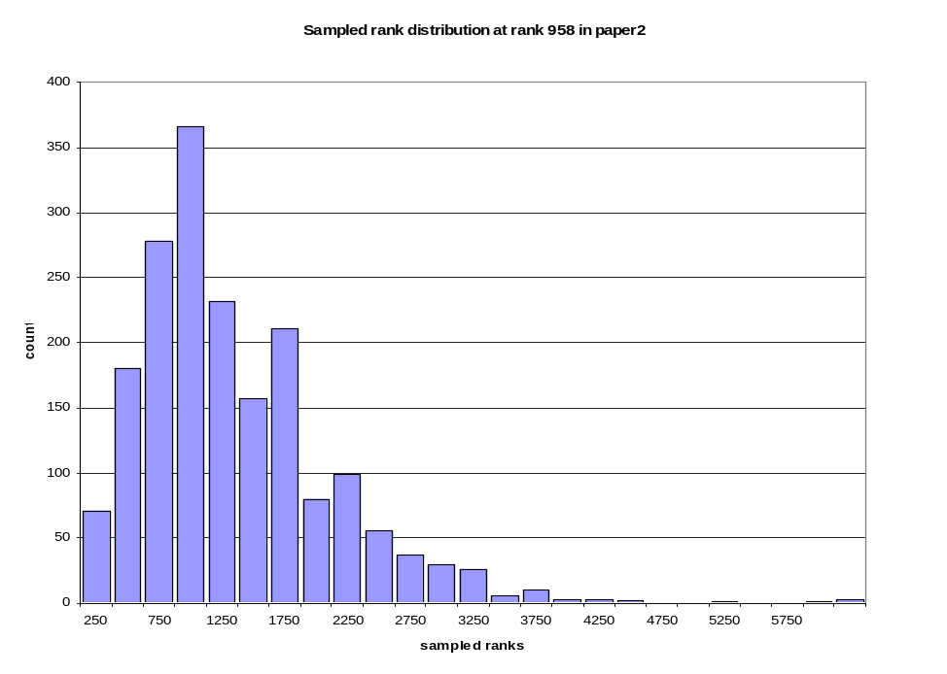

We have performed this analysis with a set of 10 sample papers. To see if the trend is dependent on the sample size ( number of papers) we repeated the analysis for a sample of 50 papers and we find a very similar histogram. This is shown in Figure 6.

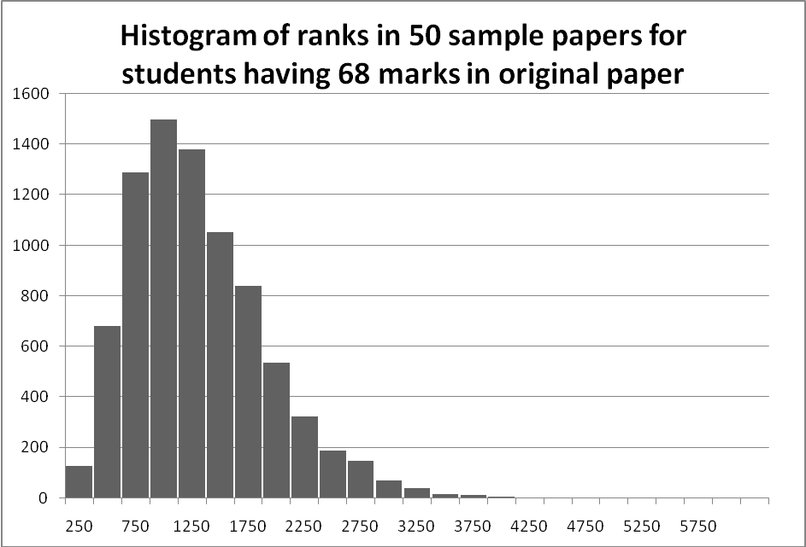

From this histogram it is clear that the inferences drawn from a sample of 10 papers ( and hence about 1000 ranks in this case) and from a sample of 50 papers ( with many more ranks) are pretty similar.

From the data, we calculate the number of “students” who are in a given range of marks. For paper I, we see that at Rank 1060 in the original paper, there were 164 students. If we take the distribution of their marks in the 10 fictitious papers, we see that roughly 50% of the students lie between rank 758 and 1521, a relatively large spread in ranks. Similarly, for paper II, the rank we have chosen is 968 and in this case the spread for 50% is between ranks 646 and 1639. It is remarkable that the two papers show a relatively similar spread.
Recall that these are students who got exactly the same marks (rank) in the original test. Furthermore, the fictitious papers that we have made are sampled from the original paper itself. But, even with this, there is indeed a spread in teh ranks. What this implies is that the exact rank that a student gets in such an examination is crucially dependent on the sample of questions that are chosen from the larger set of questions.
This result is of profound consequence to the dynamics of Multiple Choice Entrance examinations. What we see is that, the same student who gets rank 1000 ( and thus, say, is admitted into the course) could as well have got rank 1500 if the paper had been similar. Clearly, at that rank he might not have made it into the course at all. We have done this analysis assuming a rank of 1000 as the cut-off for admission, but clearly the conclusion will hold for any other rank as well. There will be significant number of students who could have obtained a lower or a higher rank- that they have got this rank is to a large extent a matter of pure chance.
Of course, this spread gets smaller as we go to higher ranks. In figure 7 we show the spread for the first 300 odd ranks. Here we see that the spread in ranks is much smaller in absolute terms, as is expected. Howerver, this graph raises another criticall issue- that of the significance of yoru absolute rank in determining the stream of yoru choice. In most entrance examinations ( engineering entrance, post graduate medical entrance etc.) , the higher yoru rank, the more choice you have in terms of paricualr subject/stream. Thus the top 50 or 100 ranks in the IIT JEE can pick any stream in any IIT that they might want and this choice decreases as one goes down in ranks.
Given that there is still a significant spread in the higher ranks, as is evident from teh fgue 7, it is once again a situation where the choice of stream is dependednt to a large extent on pure chance.

Paper I (1060-68) 382, 758,1521,2522
Paper II (968-73) 316,646,1639,2710

Thus only (one third) 40% of the 1000 candidates above the cut-off would be expected to remain above cut-off in most papers. One extremely satisfying feature of the analysis is that these limits are same in the two papers where the marks obtained are reasonable different.
This data thus supports the perception that getting into merit list is a matter of chance, except for a miniscule minority way up in the merit list. The most important fallout of the study is that the stigma associated with not getting into IIT test or medical test is definitely misplaced.
One would also feel that this error does not in anyway affect the most talented; even there we find that up to the rank 250 the rank 1 is within the error bars. In layman’s language any in the top 250 had some chance to occupy the rank 1. Thus a very rigid criterion applied as to what disciple the student should be allotted also does not look very reasonable.
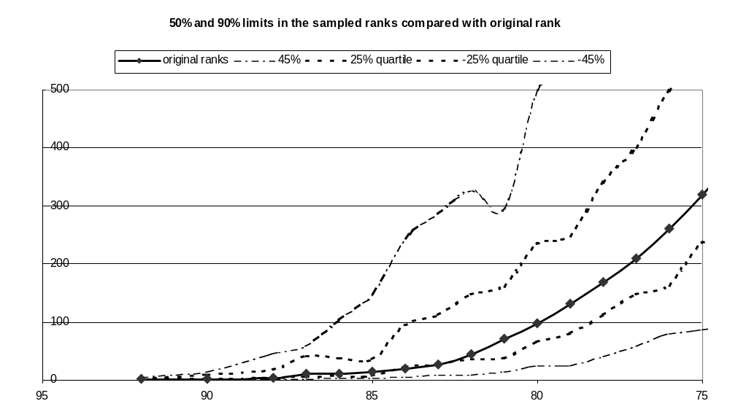

The use of thus is clearly wrong as the conclusion does not follow directly from the above data but from the fact that at the rank 391 the upper limit of the fluctuation along with root 2 factor becomes higher than 100

