Question Set1 (Question/Exercise/Activities) for Class 1
Q1. Send an email containing your name and roll number to my email address (vikasmadan.srcc@gmail.com) so that you can be enrolled in the google group.
Q2. Perform a readiness check of your understanding of computer skills by providing a self-assessment score in the range of 0 to 10 for each topic(s) mentioned in the test given in the following file Q1.2.xls.
Q3. Convert the above given survey into a smaller 2 page survey in the form of a MS word document.
Hint: There are many styles in which you can create the survey. Collect some sample surveys.
Q4. The most recent practice of conducting survey is through web forms. Find out how surveys can be designed and conducted through web. Convert the above given survey into a web survey. Enumerate the advantages and disadvantages of using web surveys.
Q5. Create your resume in at least four different formats using MS Word document. Convert your resume as a pdf document later.
Hint: Consult various formats of resumes available in MS Word templates and on the Internet. Some of the websites for resume samples and tips are:
http://susanireland.com/resume-examples/chronological-resume-sample-certified-public-accountant-cpa/
https://www.thebalance.com/free-resume-examples-and-writing-tips-2063596
https://www.bing.com/images/search?q=sample+resumes&qpvt=sample+resumes&qpvt=sample+resumes&qpvt=sample+resumes&FORM=IGRE
Q6. Change your resume to suit the following vacancies as given below.
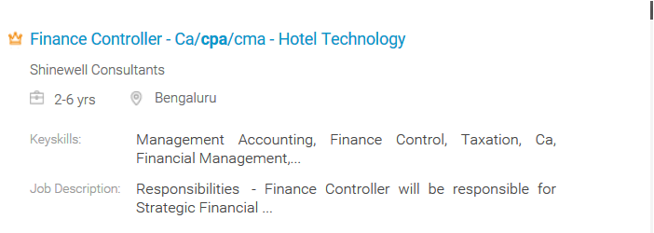
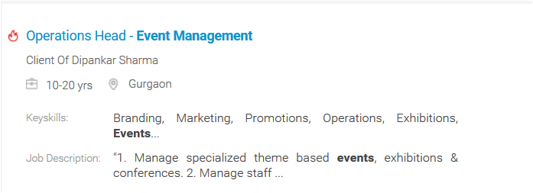
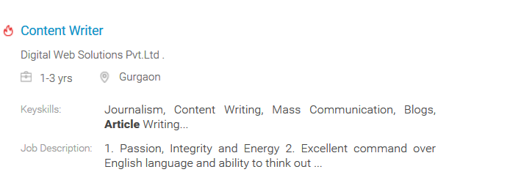
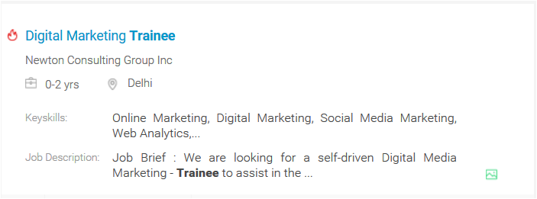
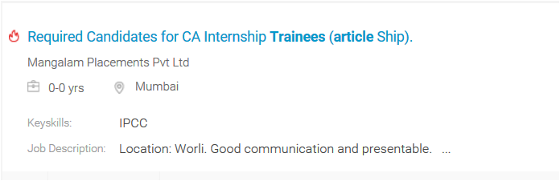
(Ref: Real vacancies advertised on Naukri.com)
Q7. These days, people are using different means to publicize about themselves. Search for other methods by which an employer is able to find about you.
Hint: Find examples of video resumes, website, blogs, Facebook pages etc.
Q8. Design a home page of your own website (i.e., the web site having your name as the url) that you intend people to visit to know about you in detail. Use MS word for creating the home page design.
Q9. Search for the computer skills requirement for jobs for commerce graduates, MBA, CA, accountants, and others.
Hint: Visit various job sites like naurki.com, monster.com, shine.com etc.
Q9. Search for the job requirement for commerce graduates with different computer skills like Tally, Excel, and Data Analytics etc.
Hint: Visit various job sites like naurki.com, monster.com, shine.com etc.
Q10. Get an idea about the kind of problems we intend to solve through this course. See Sample Questions

