Question Set1 for Class 2
(Question/Exercise/Activities)
Q1. Reproduce the following output using MS Word.
Comparison of Decision Support System with
Executive information system

A comparison by examining certain basic features that are common to both. the systems is the best approach. This type of approach helps understand:
- comparison by analysis
- essentials of systems
- dynamics of systems

 | Features | Decision Support System | Executive Information System
 | Nature of Expertise | Detailed training for problem | Brief training for specific
 |  | solving | uses
 | Communication | Ability to Collect data from | Ability to Collect data from
 |  | diverse sources | Specific files and records.

Hint: Please make a note that text at different places uses different alignments and line spacing. Also notice that list does not start with 1.

Q2. Reproduce the following outputs using MS Word.
A Statement of materials is prepared for every item of raw material. Thes statement is useful in providing:
- description of items received and issued
- total quantity receicved and issued
the format of this statement is given below:

Statement of Raw Material
Item Code: _________________Name of Item: ___________________

 | Date | Particulars | Receipts |  |  | Issues
 |  |  | Qty | Price | Total | Qty | Price | Total
 | . |  | .
 | Total
 |  |  | Balance c/d

Q2. Reproduce the following outputs using MS Word.

Special Features of your Citibank Card

International Acceptance – Accepted over 30 million establishments worldwide
24-Hour ATM Access – Access cash at over 8,10,000 ATMS across the globe

SHEDULE OF CHARGES
Description of charges | Citibank Cards | Diners Club International Cards
Cash Advance –  Transaction Fees | 2.5% on advanced amount (subject to a minimum of Rs. 250 and US $5 at International ATMs) | 3% on advanced amount  (subject to a minimum of  Rs. 250 and US $5 at  International ATMs)
Late Payment Charges (per month) | - Rs. 300 for billed amounts of less than or equal to Rs. 20,000  - Rs. 400 for billed amonts between Rs. 20,000 & Rs. 30,000 | - 2.95% - Payments overdue by 30 days.  - 5% - Payments overdue  by 60 days or more
Over Credit Limit Charge | 2.5% over the Credit Limit | ---------

Q3. Reproduce the following outputs using MS Word.
Site Contents | Log on to
:: Direct Tax  Laws | News…
:: Company Law | - FEM (Export of  Goods and Services)  - Straight through | - Amendments to Prudential Norms  - FEM (Borrowing and Lending)
:: SEBI
:: SCRA
:: FEMA | processing services  - Amendents to SEBI  - Guidelines

Q4. Reproduce your time table for an A4 size sheet using MS Word.
Q5. Reproduce the pay slip of an employee using MS Word.

Q6. Reproduce a calendar or month of a calendar using MS Word.
Q7. Reproduce the pay slip of an employee using MS Word.
Q8. Reproduce the following text using MS Word.

Y
ou don’t know about me without you have read a book by the name of The Adventures of Tom Sawyer; but that ain’t no matter. That book was made by Mr. Mark Twain, and he told the truth, mainly. There were things which he stretched, but mainly he told the truth. That is nothing. I never seen anybody but lied one time or another, without it was Aunt Polly, or the widow, or maybe Mary. Aunt Polly—Tom’s Aunt Polly, she is—and Mary, and the Widow Douglas is all told about in that book, which is mostly a true book, with some stretchers, as I said before.

“Learn to enjoy every minute of your life. Be happy now. Don't wait for something outside of yourself to make you happy in the future. Think how really precious is the time you have to spend, whether it's at work or with your family. Every minute should be enjoyed and savored. “
- Earl Nightingale

Tom and me found the money that the robbers hid in the cave, and it made us rich. We got six thousand dollars apiece - all gold. It was an awful sight of money when it was piled up. Well, Judge Thatcher he took it and put it out at interest, and it fetched us a dollar a day apiece all the year round—more than a body could tell what to do with. The Widow Douglas she took me for her son, and allowed she would civilize me; but it was rough living in the house all the time, considering how dismal regular and decent the widow was in all her ways; and so when I couldn’t stand it no longer I lit out. I got into my old rags and my sugar-hogshead again, and was free and satisfied. But Tom Sawyer he hunted me up and said he was going to start a band of robbers, and I might join if I would go back to the widow and be respectable. So I went back.

Q9. Reproduce the following output.
Days
Periods
Hint: Use the vertical text direction for cell in which “Periods” is written.
Q10. Reproduce the following output (excerpt taken from https://en.wikipedia.org/wiki/Rose).
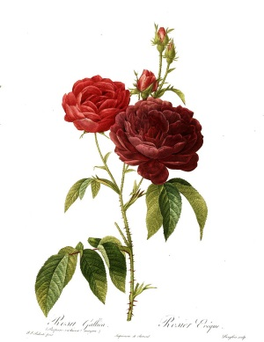
A rose is a woody perennial flowering plant of the genus Rosa, in the family Rosaceae, or the flower it bears. There are over a hundred species and thousands of cultivars. They form a group of plants that can be erect shrubs, climbing or trailing with stems that are often armed with sharp prickles. Flowers vary in size and shape and are usually large and showy, in colours ranging from white through yellows and reds. Most species are native to Asia, with smaller numbers native to Europe, North America, and northwestern Africa. Species, cultivars and hybrids are all widely grown for their beauty and often are fragrant. Roses have acquired cultural significance in many societies. Rose plants range in size from compact, miniature roses, to climbers that can reach seven meters in height. Different species hybridize easily, and this has been used in the development of the wide range of garden roses.
A rose is a woody perennial flowering plant of the genus Rosa, in the family Rosaceae, or the flower it bears. There are over a hundred species and thousands of cultivars. They form a group of plants that can be erect shrubs, climbing or trailing with stems that are often armed with sharp prickles. Flowers vary in size and shape and are usually large and showy, in colours ranging from white through yellows and reds. Most species are native to Asia, with smaller numbers native to Europe, North America, and northwestern Africa. Species, cultivars and hybrids are all widely grown for their beauty and often are fragrant. Roses have acquired cultural significance in many societies. Rose plants range in size from compact, miniature roses, to climbers that can reach seven meters in height. Different species hybridize easily, and this has been used in the development of the wide range of garden roses.
ROSE
Hint: Use picture position, picture border, wrap text for picture, picture angle and transparency features
Q11. Reproduce the following (Excerpts taken from Wikipedia – Rose). Create each link to its corresponding Wikipedia page. For example North_America will be linked to the URL https://en.wikipedia.org/wiki/North_America. Also link the picture to the URL : https://en.wikipedia.org/wiki/Rose#/media/File:Redoute_-_Rosa_gallica_purpuro-violacea_magna.jpg
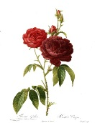
A rose is a woody perennial flowering plant of the genus Rosa, in the family Rosaceae, or the flower it bears. There are over a hundred species and thousands of cultivars. They form a group of plants that can be erect shrubs, climbing or trailing with stems that are often armed with sharp prickles. Flowers vary in size and shape and are usually large and showy, in colours ranging from white through yellows and reds. Most species are native to Asia, with smaller numbers native to Europe, North America, and northwestern Africa. Species, cultivars and hybrids are all widely grown for their beauty and often are fragrant. Roses have acquired cultural significance in many societies. Rose plants range in size from compact, miniature roses, to climbers that can reach seven meters in height. Different species hybridize easily, and this has been used in the development of the wide range of garden roses.
Hint: Use hyperlink
Q12. Reproduce the following matter in the form of a MS Word document. (Excerpts from Wikipedia – Annuity page https://en.wikipedia.org/wiki/Annuity)

Annuity
An annuity is a series of equal payments at regular intervals. Examples of annuities are regular deposits to a savings account, monthly home mortgage payments, monthly insurance payments and pension payments. Annuities are classified by the frequency of payment dates. The payments (deposits) may be made weekly, monthly, quarterly, yearly, or at any other interval of time. An annuity which provides for payments for the remainder of a person's lifetime is a life annuity.
Valuation of Annuity
Valuation of an annuity entails calculation of the present value of the future annuity payments. The valuation of an annuity entails concepts such as time value of money, interest rate, and future value
The present value of an annuity is the value of a stream of payments, discounted by the interest rate to account for the fact that payments are being made at various moments in the future. The present value is given in actuarial notation by:
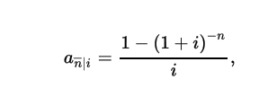
where is the number of terms and is the per period interest rate. Present value is linear in the amount of payments, therefore the present value for payments, or rent is:
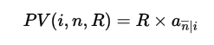
In practice, often loans are stated per annum while interest is compounded and payments are made monthly. In this case, the interest is stated as a nominal interest rate, and 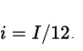.
The future value of an annuity is the accumulated amount, including payments and interest, of a stream of payments made to an interest-bearing account. For an annuity-immediate, it is the value immediately after the n-th payment. The future value is given by:
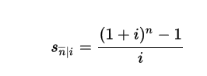
where n is the number of terms and i is the per period interest rate. Future value is linear in the amount of payments, therefore the future value for payments, or rent R is:
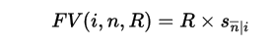
Proof of annuity-immediate formula
To calculate present value, the k-th payment must be discounted to the present by dividing by the interest, compounded by k terms. Hence the contribution of the k-th payment R would be R/(1+i)^k. Just considering R to be one, then:
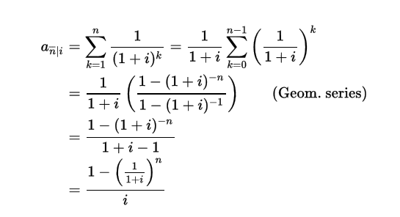
Similarly, we can prove the formula for the future value. The payment made at the end of the last year would accumulate no interest and the payment made at the end of the first year would accumulate interest for a total of (n−1) years. Therefore,
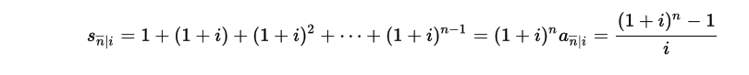
Q13. Using MS Word, create a report that recommends five students to be nominated for scholarship. Provide the list of 20 student applicants along with their attendances for the past 12 months arranged in the order of their percentage of attendance. The first page should be of portrait orientation while the second page should be of landscape orientation as the details of the students will require a wider row.
Hint: Calculate the sum and percentage values on its own table and sorting of the table. See the following arrangement of pages. Use section break.
Page 1
Page 2
Q14. Using MS Word, reproduce* some pamphlets/advertisements/articles that you can find from newspapers, magazines etc. Some of these are given below for your quick reference. Do pick some examples that use languages other than English like Hindi.
* Remember that you may not be able to reproduce all outputs in exactly the same way. Try to reproduce the output as much as you can. Please bear in mind that MS Word is primarily documentation software and is not suitable for highly sophisticated designs.
